Figure Counting

Q :1. In the following question number of triangle are
(A) 21
(B) 23
(C) 25
(D) 27
Q : 2. Find the number of triangle in the given figure.
(A) 12
(B) 18
(C) 22
(D) 26
Q : 3. In the question find the number of triangles.
(A) 27
(B) 25
(C) 23
(D) 21
Q : 4. In question below shown, count the number of triangle and squares.
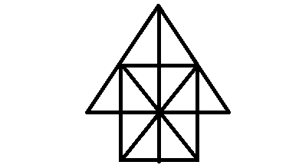
(A) 26 triangles, 5 squares
(B) 28 triangles, 5 squares
(C) 26 triangles,6 squares
(D) 28 triangles, 6 squares
Q : 5. In the following questions, count the number of triangles and squares in the given figure.
(A) 44 triangles,10 squares
(B) 14 triangles, 16 squares
(C) 27 triangles,6 squares
(D) 36 triangles, 9 squares
Q : 6. Direction-1 How many triangles in the figure?
(A) 16
(B) 19
(C) 10
(D) 25
Q : 7. Find the number of triangles in the figure.
(A) 20
(B) 24
(C) 28
(D) 32
Q : 8. How many triangles in the figure?
(A) 16
(B) 14
(C) 8
(D) 12
Q : 9. How many squares in the figure?
(A) 16
(B) 17
(C) 26
(D) 30
Q : 10. How many triangle is in the given figure?
(A) 10
(B) 12
(C) 14
(D) 16

- D
- B
- A
- A
- A
- D
- C
- A
- D
- A

